

University of Piraeus

Department of Digital Systems

Course: Environmental and Climate Change Systems and Policies

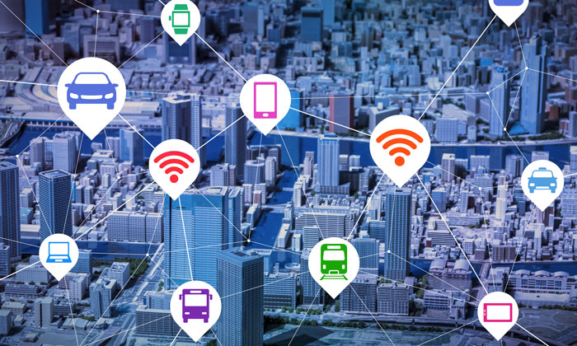

**Konstantinos Chikimtzis**

SUpervisor: prof. Yannis maniatis

Digital Systems Solutions for Traffic Congestion

Piraeus, 2020

The Problem 2

**Climate Crisis** 3

**Greenhouse Gasses** 4

**The Urbanization Problem** 6

**Urban Mobility** 10

**Congestion** 11

**Air Pollution & CO2** 12

**Overall** 13

The Goal 15

Urban Mobility Solution: Smart Traffic 17

# The Problem

### **Climate Crisis**

In October 2019, more than **11,000** Scientists around the world declare ‘Climate Emergency’.

This is the first time a large group of scientists have jointly used the word "emergency" when talking about climate change. “Climate change has arrived and is **accelerating** faster than many scientists expected.”

The current **global average temperature is 0.85ºC higher** than it was in the late 19th century. Each of the past three decades has been warmer than any preceding decade since records began in 1850.

In **Europe** temperatures have repeatedly broken long-term records in recent years. Some observed and projected climate change impacts for the Mediterranean region in Europe are:

* Large increase in heat extremes
* Increase in mortality from heat waves
* Decrease in summer tourism and potential increase in other seasons
* Increase in multiple climatic hazards
* Most economic sectors negatively affected

***Source:*** *EEA, 2017, Climate change, impacts and vulnerability in Europe 2016 – An indicator-based report, EEA Report No. 1/2017.*

***Source****:* [*Knowledge for a sustainable Europe*](https://www.eea.europa.eu/publications/eea-snapshot)

### **Greenhouse Gasses**

Our planet is experiencing significant and accelerated climate change **caused by greenhouse gases** emitted by human activities.

The effects are being felt on all continents and are predicted to become more and more intense, with severe consequences for our economies and societies.

**What Are Greenhouse Gasses?**

Some gases in the Earth's atmosphere act a bit like the glass in a greenhouse, trapping the sun's heat and stopping it from leaking back into space.

Many of these gases occur naturally, but human activity is increasing the concentrations of some of them in the atmosphere, in particular:

* carbon dioxide (CO2)
* methane
* nitrous oxide
* fluorinated gases

**CO2** is the greenhouse gas most commonly produced by human activities and it is **responsible for 64% of man-made global warming**. Its concentration in the atmosphere is currently 40% higher than it was when industrialization began.

One of the main causes for the rising emissions is the **burning of coal, oil and gas** as it produces carbon dioxide and nitrous oxide.

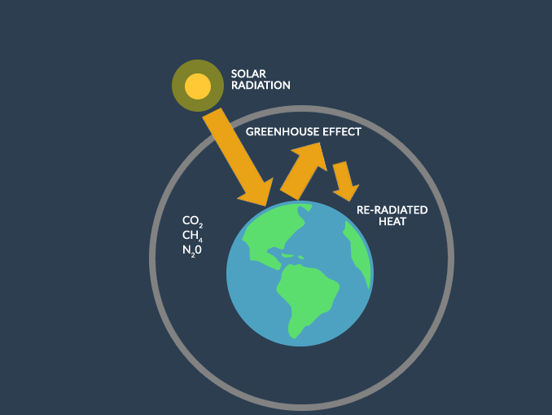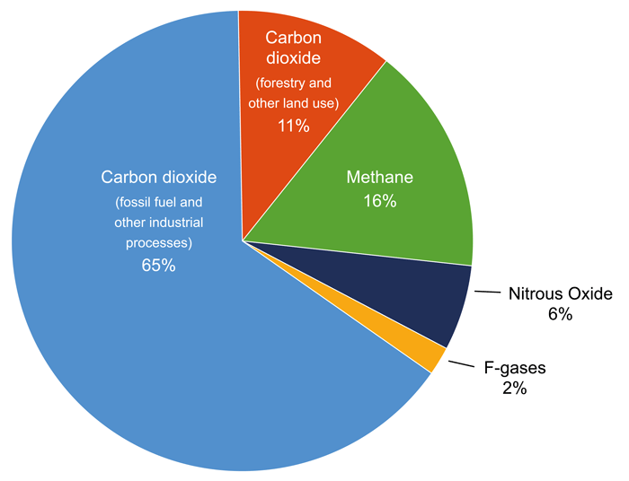

***Source****: Contribution of Working Group III to the Fifth Assessment Report of the Intergovernmental Panel on Climate Change*.

### **The Urbanization Problem**

**International**

**Cities are major contributors to greenhouse gas emissions**. Half of the world’s population lives in cities, a share that is likely to reach 70 percent in 2050. Cities consume as much as 80 percent of energy production worldwide and account for a roughly equal share of global greenhouse gas emissions.

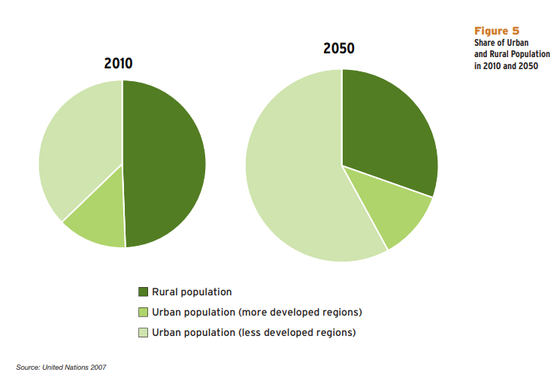

***Source****:* [*United Nations 2007*](https://www.un.org/en/development/desa/population/publications/pdf/urbanization/2007_urban_rural_chart.pdf)

The International Energy Agency (IEA) estimates that urban areas currently account for over 67 percent of energy-related global greenhouse gases, which is expected to rise to 74 percent by 2030. It is estimated that 89 percent of the increase in CO2 from energy use will be from developing countries (IEA 2008).

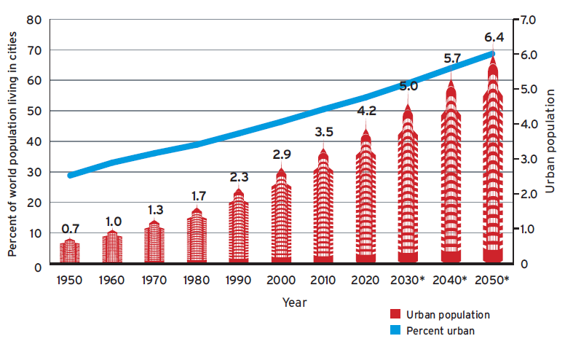**Urban population is expected to double by 2030, however the global built-up area is expected to triple during the same period**. This building out instead of building up will dramatically increase energy requirements and costs of new infrastructure. Poorly managed cities exacerbate enormous new demands for energy and infrastructure investment.

***Source****: UN, Department of Economic & Social Affairs, Population Division.*

**Europe**

In 2010, 73% of European citizens lived in urban areas. It is expected

that this percentage will increase to over **80% by 2050**. In some

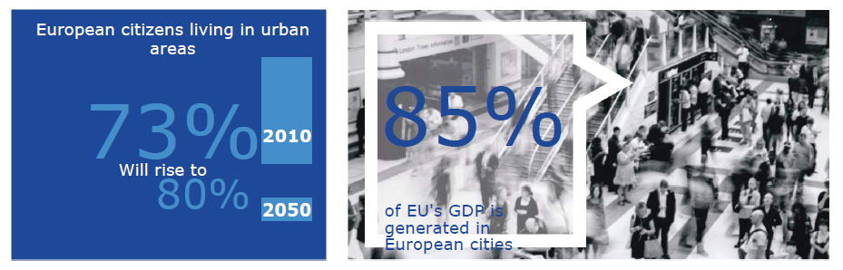countries like Sweden, Belgium, the Netherlands, Denmark, Malta and Luxembourg the urbanization rate will rise to over 90%.

***Source****:* [*European Urban Mobility - Policy Context*](https://civitas.eu/document/european-urban-mobility-policy-context)

On average, the European network of cities **is denser than in other parts of the world**, with predominantly mid-sized rather than large cities. European cities, with a density of 3 000 residents per km2, are almost twice as dense as North American ones, but less dense than those in Africa and Asia. The majority of Europeans are concentrated in cities with populations between 250 000 and 5 million.

**JRC projections to 2030 show that most European regions hosting major cities are expected to experience urban population growth** *(Figure 7, top)*. Indeed, some regions will see significant growth in their urban population (greater than 35%, and up to almost 60% in Stockholm), particularly in southern France, northern Italy and southern Germany. However, population decline is foreseen in core cities in Spain (Madrid, Barcelona and Valencia), Portugal (Porto), and Lithuania (Vilnius), and in clusters of regions throughout most of Eastern Europe, Germany, and the Iberian Peninsula (35% and above).

***Source:*** [*The Future of Cities*](https://ec.europa.eu/jrc/en/publication/eur-scientific-and-technical-research-reports/future-cities)

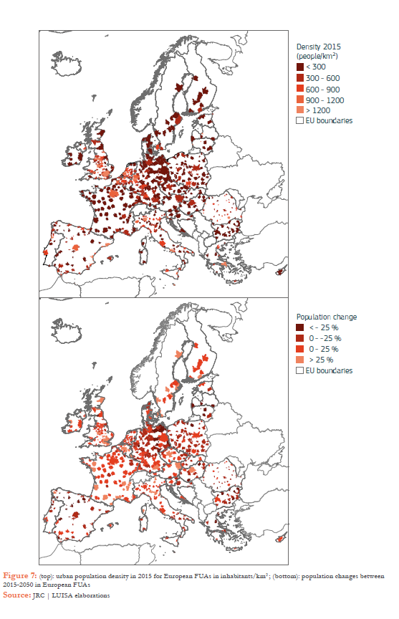

### **Urban Mobility**

Transport remains one of the biggest challenges for decarbonizing the economy and with urbanization increasing, problems occur.

Urban transport systems are **vital** to the economic functioning of

cities through their provision of accessibility for goods and

commuters. Similarly, they are vital to the welfare of the population

by providing accessibility for all social activities.

However, due to the extensive economic activity in urban areas, many European cities face several problems related to or caused by **transport and traffic**. Economic and social transformation has rapidly increased the levels of mobility. **The growth of private car use has been accompanied by increased urban sprawl and commuting**, whereas the expansion of public transport networks in many cases has not been developed at the same rate.

At the same time transport systems can generate negative

external effects.

**Congestion, air and noise pollution** are examples of commonly shared problems in European cities. Besides this direct

impact, urban transport also affects social development, social inclusion and accessibility for people with reduced mobility. European cities face the challenge of how **to enhance mobility, ensure accessibility**, and create high quality and efficient transport systems while at the same time **reducing congestion, pollution and accidents.**

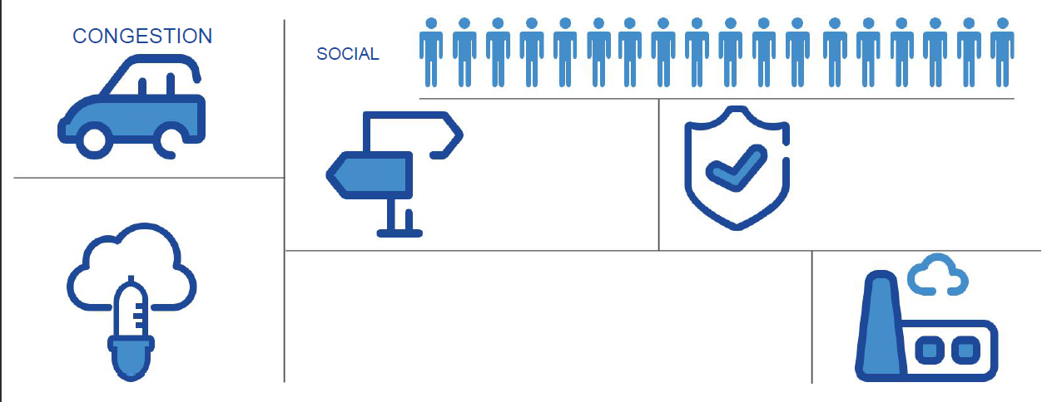

### **Congestion**

Congestion in urban environments is a complex phenomenon with

many dimensions: demographic, social and economic characteristics,

land use patterns, car-ownership, availability of public transport,

availability of parking, and urban freight transport and goods

delivery. These are all factors that influence the level of congestion and they are **important to understand** so we can think of solutions.

These factors shape activity patterns, which in turn generate a demand for travel. This demand for travel results in

traffic on the urban road network. **When the volume of car traffic**

**exceeds available capacity, congestion arises**.

The average percentage delay in 2013 in percentages compared to

the "free flow” situation in a sample of 58 EU cities ranges from **14%**

**in Malmö** (Sweden) to **39% in Palermo** (Italy). During peak hours the

delays are substantially higher.

The cost of congestion in Europe is still high, estimated at around

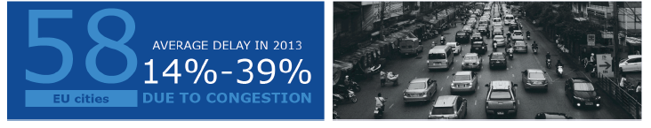EUR **130 billion annually**, or just over one percent of the EU's GDP.

Congestion does not only damage the economy, but it damages people’s health too.

***Source****:* [*European Urban Mobility - Policy Context*](https://civitas.eu/document/european-urban-mobility-policy-context)

### **Air Pollution & CO2**

Congestion leads to air pollution. **The main factors** determining air pollution caused by road traffic are:

**Volume of traffic Speed / congestion Propulsion types**.

Transport also contributed to **13%** and **15%** of total PM10 and PM2.5 primary emissions, respectively, in the EU‑28 in 2014. (Source EEA Air Quality in Europe Report 2016).

In fact, around **85 % of city dwellers in Europe are exposed to fine particulate matter** (PM2.5), which is estimated to reduce average life expectancy in the EU by more than **8 months**.

***Source:*** [*Knowledge for a sustainable Europe*](https://www.eea.europa.eu/publications/eea-snapshot)

**CO2 emissions** from road freight transport were **33% higher** in 2012

than in 1990 and made up 35% of total transport emissions.

### **Overall**

Urbanization



Urban Mobility Problems

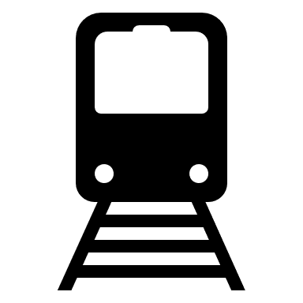



Congestion

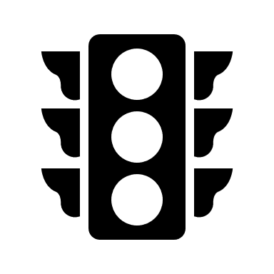

Greenhouse Gasses



The world's leading climate scientists think **human activities like urban mobility are almost certainly the main cause of the warming** observed since the middle of the 20th century.

With urbanization and the use of the private car increasing, traffic congestion is nowadays one of the biggest problems Europe faces and actions are already being taken.

Clean air is essential for our health, our environment and our economy. Our planet is experiencing significant and accelerated climate change caused by greenhouse gases emitted by human activities.

The scale of financial resources needed to effect sustainability transitions is daunting. The costs of inaction may be even greater. It is estimated that EUR 1 Trillion worth of investments is needed,

annually, from 2021 onwards, to meet the EU's 2030 climate and energy targets.

# The Goal



The effects of climate change are being felt on all continents and are predicted to become more and more intense, with severe consequences for our economies and societies.

To stop climate change from getting worse, we must take action to **cut greenhouse gas emissions significantly** and adapt to the changes happening now and, in the future, to limit the damage.

The Paris Agreement sets out a global framework to avoid dangerous climate change by limiting global warming to well **below 2°C** and pursuing efforts to **limit it to 1.5°C**. It also aims to strengthen countries’ ability to deal with the impacts of climate change and support them in their efforts.

The overall aim is to reduce greenhouse gas emissions, air pollution and noise levels **as well as congestion**. As a result, there will be big savings in health costs and pollution control measures.

* For 2030, the EU has set targets to achieve a **40%** reduction in greenhouse gas emissions.
* Also, the EU is aiming for a [**60% cut in transport emissions**](http://ec.europa.eu/transport/themes/strategies/2011_white_paper_en.htm) by 2050 compared to 1990.

The core elements of the strategy to achieve this are:

* **Increasing the efficiency of the transport system**by making the most of digital technologies, smart pricing and further encouraging the shift to lower emission transport modes.
* **Speeding up the deployment of low-emission alternative energy for transport,**such as electricity.
* **Moving towards zero-emission vehicles.**

***Source****:* [*A European Strategy for low-emission mobility*](https://ec.europa.eu/clima/policies/transport_en)

We are going to focus mainly on the first element of the strategy: **Making the most of digital technologies to increase the efficiency of the transport systems** **and fight congestion** in European cities. Improving congestion will certainly cut down transport emissions and make our commutes more pleasant.

# Smart Traffic Management

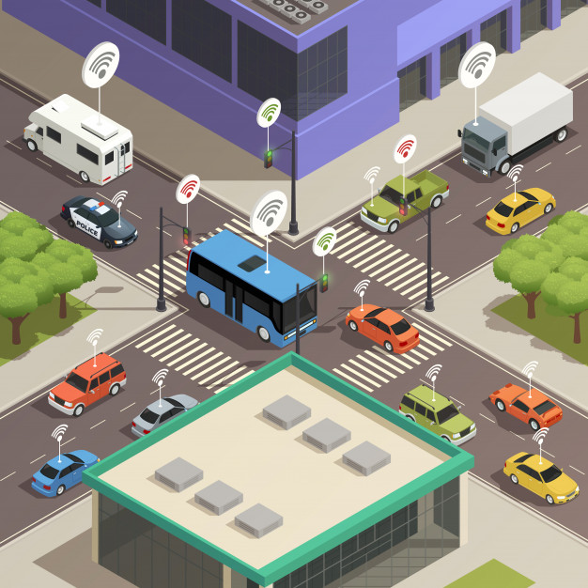

A very sustainable urban mobility solution is smart traffic management. The implementations of smart traffic solutions vary from city to city, so we need to first understand the fundamental concepts of these solutions.

### **What is Smart Traffic Management?**

Smart traffic management incorporates a range of technologies and a myriad of data sources to control or support control of **traffic based on real-time traffic congestion levels** and other conditions.

Some intelligent traffic management systems integrate with transit data incorporating scheduleand on-time performance data of scheduled bus and rail routes. In addition, intelligent traffic management helps build a rich database of mobility information, which can contribute to further traffic and mobility improvements.

Some **elements** of smart traffic management include:

1. Signalling that adapts automatically to congestion and road traffic conditions.
2. Collecting vehicle movement data throughout the city
3. Integrating with transit data.
4. Analysis of roadway and intersection performance.
5. Sensing pedestrians and bicycles and integrating this data.
6. Integration with emergency vehicles.

With smart traffic control, a smart intersection automatically adapts to real-time congestion and roadway conditions. A typical traffic signal cycle is fixed in duration, while a smart intersection has flexible, adaptive signal cycles. A system of **smart intersections can identify and calculate the queue of cars at an intersection and at other intersections to eliminate congestion**. For example, after a sporting event or a concert, traffic can be cleared faster than the normal signal timing would allow.

Smart traffic management allows for the collection **of vast amounts of mobility data** that can be used for city, resource and transit planning, as well as for policy development. For example, pedestrians and vehicles by type (e.g. bicycle, car, bus, and truck) can be counted by time of day, direction, speed and movement/turns.

Also, by detecting pedestrians and bicycles and their movements using sensors, image processing and algorithms can be used to calculate trajectories and the potential for contact of pedestrians and bicyclists with vehicles in the street and communicate this information to approaching vehicles in traffic.

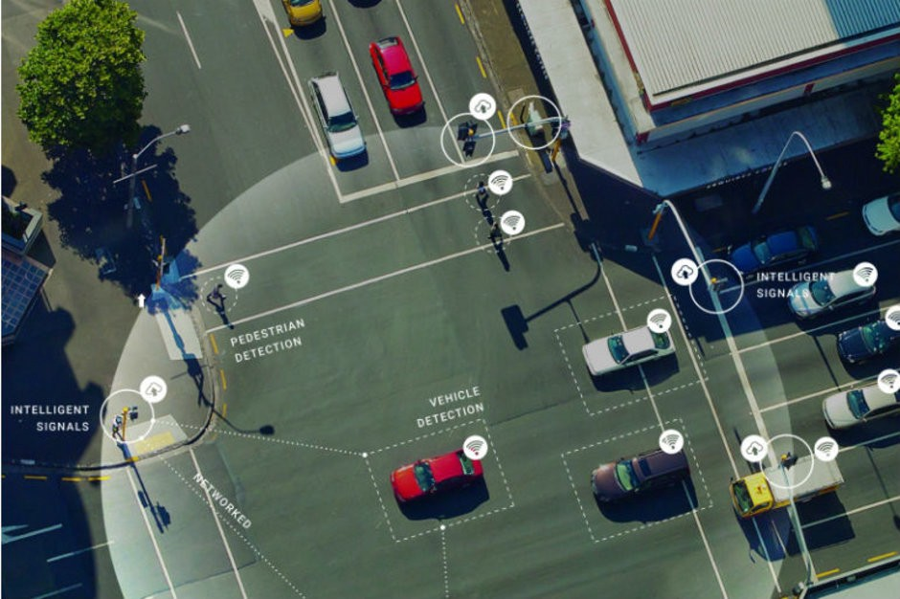Signal pre-emption for emergency vehicles and signal priority for street-running transit systems already exist, however, there is a need for improvement. For example, emergency signal pre-emption generally stops all nonemergency traffic. As a result, intersections are sometimes clogged with stopped cars, making it difficult for a large vehicle, such as a fire truck, to navigate through. In other instances, emergency responding vehicles entering an intersection from perpendicular streets have crashed into each other as all four directions were given a green signal. Intelligent traffic management can better coordinate emergency response. For transit vehicles that operate on city streets, intelligent traffic management could shorten trip times, enhance on-time performance and reduce operating costs.

### **How Smart Traffic Management Works**

We can split the smart traffic management system infrastructure in 3 layers:

* Data Acquisition and Collection Layer.
* Data Computation and Processing Layer.
* 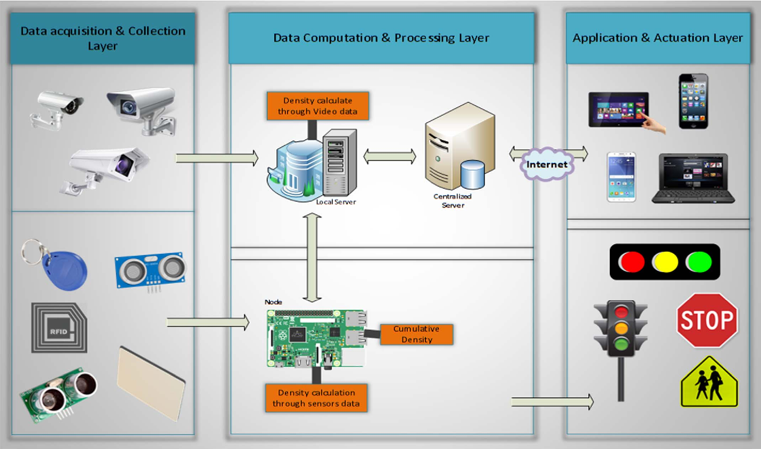Application and Actuation Layer.

***Source:*** [*Smart traffic management system using Internet of Things*](https://www.semanticscholar.org/paper/Smart-traffic-management-system-using-Internet-of-Javaid-Sufian/ccafb1bca5c2a47211870b11af2e24e348f05563)

Like all digital systems, this system has some input data that passes through a computation phase and finally outputs some new data.

* **Data Acquisition and Collection Layer**

Smart traffic management incorporates intelligence- and communications-enabled roadways and intersections with data collected from **sensors**, **cameras**, **vehicles**, **GPS**, **mobile** **devices**, **transit timetables**, and other sources.

* **Data Computation and Processing Layer**

Computations and analytics can be performed in the **Cloud** or **at the Edge**, depending on the need and requirements for **speed** and **scalability**.

For **safety-critical functions**, **communications** **must be super-low latency**. Dedicated short-range communication (DSRC) is one communications platform, while 5G is currently in development as a more ubiquitous solution.

For **non-safety-sensitive** transmissions and for activities like monitoring the signal network or performing remote maintenance, **slower communications platforms may be acceptable** and, in general, the traffic signal controllers must be connected to the internet.

* **Application and Actuation Layer**

A systems approach analyzes data across geographies and modes. For example, if traffic is congested in an area five miles away from a driver near his/her destination, **the system will know not to advise the driver to use a road through that area**. Meanwhile**, traffic signals will change based on the length of traffic queues** at the signal and in the surrounding area.

Besides this, **RFIDs** will also be used to **prioritize the emergency vehicles** like ambulance, fire brigade etc. by implementing RFID tags in such vehicles. In the case of emergency situations, such as fire explosion or burning of something, fire and smoke sensors are also deployed on the road to detect such situations.

### **Weakness in Current Traffic Control System**

Almost all urban cities in the world use traffic lights to control

the traffic on the roads. The lights switch from red, which

means stop, to green, which means move. Over time there has

been developments of different types of traffic light control

systems, the most commonly used being static traffic lights

and vehicle actuated lights.

**Static traffic lights’** timing and switching patterns are

predetermined despite prevailing traffic conditions for the

different lanes. **They do not operate with real time data**.

Consequently, this means they do not take into account the

non-uniform and ever-changing nature of traffic conditions. It

does not matter whether at a particular time of day, route

one has more cars than route two; the green light allocation

time and pattern still remains the same for all routes. The lack

of intelligent strategies in these devices does very little in

improving the road network performance and traffic

congestion levels.

**Vehicle-actuated traffic lights** were an attempt to enhance the

static lights. They combine pre-set time cycles with proximity

sensors. These sensors can activate a change in the cycle time

or the lights when cars are present. This is due to the

assumption that roads with fewer cars may not need a regular

cycle of green lights. However, the downside of these traffic

lights is that they are **not adaptive**. They depend on having

some prior knowledge of traffic flow patterns at the

intersection so that signal cycle times and placement of

proximity sensors may be customized for the intersection.

This means that the signal time/extension is still a fixed value.

Also, proximity sensors will only activate a change in signal

light when cars are present, they do not count cars.

***Source****:* [*Techniques for Smart Traffic Control: An In-depth*](http://www.ijcat.com/archives/volume4/issue7/ijcatr04071014.pdf)

### **Smart Traffic Lights**

Smart traffic light controls are **dynamic**. This means that they

use real time data to make priority-based decisions. They use

advanced communication systems based on sensors and/or

RFID tags to collect data and provide the system with information on the current situation on the roads (such as number of vehicles on individual roads or how long vehicles have been waiting for green light). The smart system then processes this information and makes decisions. Τhat is, it automatically determines the duration of each traffic light signal based on prevailing traffic situation on the roads.

Commonly used systems include fuzzy expert systems (FES), artificial neural networks (ANN) and wireless sensor networks (WSN).

**How can they help?**

Smart management of traffic signal lights can reduce congestion and make traffic flow more smoothly in cities by using a **signal priority system**. This system gives certain vehicles a green light faster than others, reducing their travel time.

Smoother traffic rhythm reduces stops and queuing, which in turn **reduces emissions**, consumption and noise.

**How this signal priority system is made?**

These systems are empowered by **AI**. AI-enable traffic lights use **machine vision to adjust to the flow of traffic**, minimizing the driving time. These traffic signals can adjust in real time to optimize traffic patterns and increase the movement of traffic.

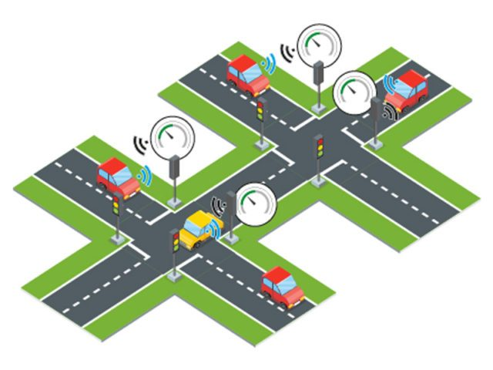Carpool lanes can be changed in real time, if needed, with **priority given to buses and rideshare vans to speed up commutes**. The public transit experience can be improved as well, with applications that keep riders informed with real-time schedules and delays so users can determine when they need to leave to catch a train in time and avoid long waiting periods.

**What about emergency vehicles?**

As the vehicle carrying an **RFID** (ambulance, fire brigade, police and other emergency vehicles) approaches a certain junction/roundabout, based on the distance programmed in the vehicle inbuilt device to triggers the traffic lights, they are automatically switched to green in order to allow movement without stopping at the junction. High priority vehicles are always in a rush to get to their destination without being inconvenienced by traffic lights. **30 or 45 sec** **can mean a lot for a life** while it tries to maneuver through heavy traffic.

# Technologies for Smart Traffic Lights

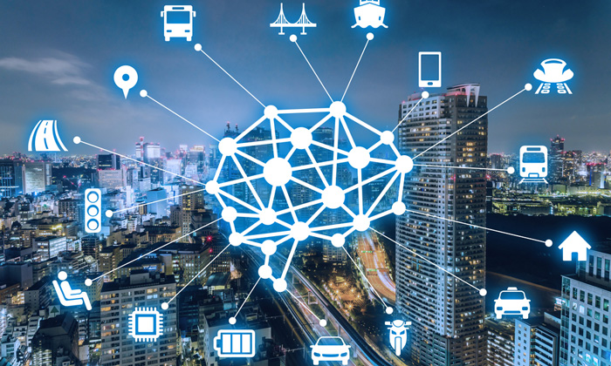

In this section we are going to examine the technology toolset there is today, to implement a smart traffic management system with intelligent traffic lights.

### **Video Image Detection System for Smart Traffic**

Vehicle detection and counting is important in computing traffic congestion and this represents the inputs to our system. The objects here are defined as vehicles moving or stopping on the roads.

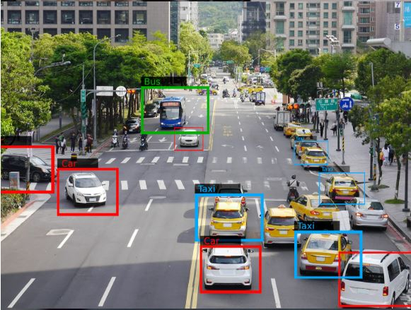There are different sizes of the vehicles that use the road, some of them **cars and buses that can be differentiated and the different traffic components can be observed and counted for violations**, such as lane crossing, vehicles parked in no parking zones and even stranded vehicles that are blocking the roads. The basic algorithm starts with a pre-image processing step, consisting of digitization and segmentation. The next step is called video segmentation which can be defined as the following: given a scene of the road without any object; captures this frame as a reference frame, which will be considered as background to our video segmentations that may contain one or more objects. The algorithm has four major functions:

* The first one is converting the video segmentation into frames and select the last frame and will call it current image.
* The second function is converting the current image to black and white in order to prepare for boundary tracing and remove the noise by using morphology functions.
* The third function subtracts the background from the current frame.
* The last function counts all distinct objects in the image.

### **Artificial Intelligence**

**Smart Agents**

An adaptive traffic signal control (ATSC) depends upon logic that ranges from the simplest example wherein green lights are assigned for each movement on a longest-queue-first basis to the most complex signal control system that depends on optimal control theory. Learning-based ATSC has recently emerged as an alternative to the existing ATSCs, and the **reinforcement-learning** (RL) algorithm is receiving the greatest share of the spotlight after it was used to solve many difficult dynamic problems. **A RL agent can control traffic signals for a single intersection or a group of intersections in real-time by continuously improving its control performance**. In addition, the RL-based model can be trained by self-generating data examples, unlike many supervised learning technologies that require a predetermined set of training data.

***Source****:* [*Artificial intelligence for traffic signal control based solely on video images*](https://www.researchgate.net/publication/321067358_Artificial_intelligence_for_traffic_signal_control_based_solely_on_video_images)

**Artificial Neural Networks (ANN)**

The input given to the ANN models are the list of data collected

by the sensors which are placed around the traffic lights. The

sensors give the traffic light ANN model all the data which

are related to the past and present traffic parameters. The

model then processes this input and selects the most suitable

output that suits current traffic situation. These results are then

used by the traffic lights to set the timing for the red and green

lights.

In a use case with this approach, it was evaluated that for the ANN

to produce accurate decisions, it required 83 neural nodes,

their system produced **73% accuracy level for the derived solutions**.

Also, there is another method called Environment Observation Method based on ANN controller (EOM-ANN). This approach is different because it also incorporates mathematical strategies

(EOM) to make signal allocation decisions. EOM is a mathematical methodology for obtaining timing plans for isolated intersections. It achieves this by calculating the minimal green time for each phase then to prevent congestion an additional green time is allocated to each lane that still has cars even after getting green light.

EOM-ANN uses the feed-forward method with 8 neural nodes

in total for input, hidden and output layers. It is further

divided into two modules; **reviser** and the **neural**. The former

defines correct traffic light timing and the latter provides the

most appropriate value for the current traffic behaviour. **The**

**inputs of the ANN are the number of light, medium and heavy vehicles.**

### **Fuzzy Expert Systems (FES)**

FES is a suitable approach to dynamic traffic signal control

because of the nature of uncertainties on road traffic where the

traffic distributions fluctuate non-uniformly. It is a superset of Boolean logic that has been extended to handle partial truths between

completely false (0) and completely true (1). This is in an

attempt to mimic or **reflect how humans think**, to model our sense

of words when describing certain phenomena as well as

our common sense in decision making. **The sensors collect**

**data from the environment which in turn is fed into the fuzzy**

**logic controller** (FLC) for processing. The inference process

in a FLC is similar to the way traffic officers handle the traffic

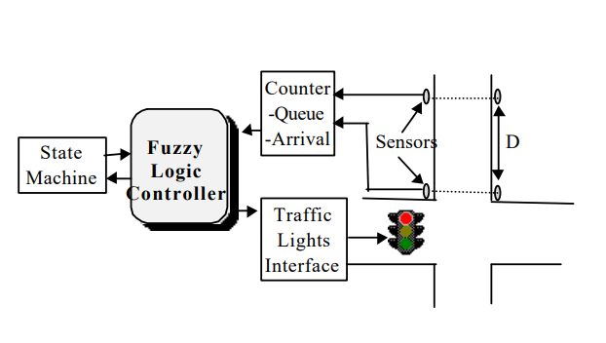flow at a typical roundabout. The FLC’s objective is to control operations in systems by making decisions that utilize rules expressed with the uncertainty of human terms such as cool (slightly cold) or warm (slightly hot). Therefore, FLCs are a suitable approach to traffic signal control because it assigns green or red light signal based on urgency or as traffic fluctuates and selects the best decision that will minimize congestion at a particular interval. For instance, a lane could also have low or medium traffic as opposed to just no traffic (0) or high traffic (1).

.

***Source****:* [*Intelligent Traffic Lights Control By Fuzzy Logic*](https://www.researchgate.net/publication/229029935_Intelligent_Traffic_Lights_Control_By_Fuzzy_Logic)

The system uses two input variables:

1. quantity of traffic on the arrival side (**Arrival**).
2. quantity of traffic on the queuing side (**Queue**) collected from the sensors on the lanes.

The system controls traffic on multiple lanes simultaneously i.e.

North and south lanes move together while east and west

lanes move together. When North and South have green light,

East and West stop (queue). The fuzzy controller observes

the density of north and south as one side and east and west as

another side. The system then determines green light allocation and **Extension** based on the side that has the highest traffic quantity.

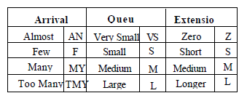

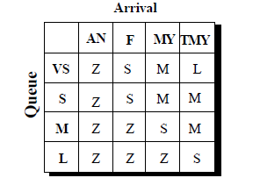

***Source****:* [*Intelligent Traffic Lights Control By Fuzzy Logic*](https://www.researchgate.net/publication/229029935_Intelligent_Traffic_Lights_Control_By_Fuzzy_Logic)

Experiments were are able to demonstrate that the fuzzy logic traffic light controller performs better than the fixed-time (static) controller.

From a comparison made between the performance of the

fuzzy logic controller and that of a fixed time (static) controller, the results was that the fuzzy logic controller had a lower average waiting time – a difference **of 6 minutes**.

### **Wireless Sensor Networks (WSN)**

In the event WSN is used to not only collect traffic data but

also actively control road traffic, additional functionalities are

incorporated into the network’s controller. **An algorithm is**

**embedded to control the traffic lights** – **it generates routing**

**decisions based on sensor data aggregated**. Unlike some A.I

systems, WSN **does not** require vehicles to have additional

systems such as RFID tags to control and manage traffic. As a

result WSN are cost inexpensive and make it a more practical

than ANN and FES approaches especially in emerging economies.

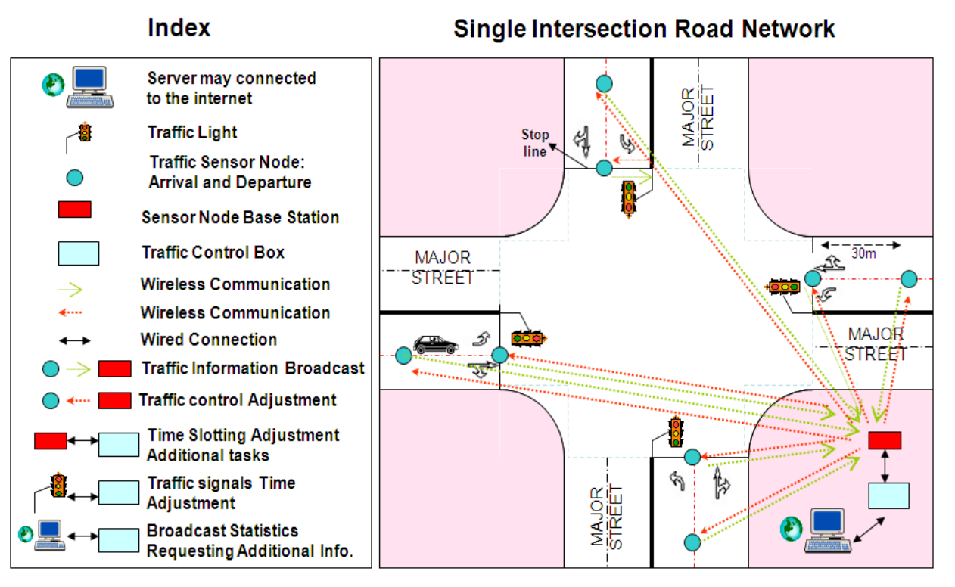

***Source****:* [*Intelligent Traffic Light Flow Control System*](https://www.iis.sinica.edu.tw/page/jise/2010/201005_02.pdf)

For a single and multiple intersections, WSN is used to route traffic based on traffic density and waiting times. **It is composed of sensors that detect the presence of vehicles** and **have a memory that stores their waiting times on each road**. Its also has an **intelligent traffic controller** that processes the sensor data then employs three algorithms.

1. A traffic system communication algorithm (**TSCA**).
2. A traffic signal time manipulation algorithm (**TSTMA**) to route traffic based on the traffic variations of all lanes of the intersections at a particular time and
3. A traffic control algorithm on multiple intersections (**TCAMI**).

**TSCA**

TSCA’s main objective is to **enable exchange of information**

**between the sensors’ base station** (BS) and **the controller**

using a direct routing scheme approach. This means all

sensors are within range of the base station and directly communicate with it.

**TSTMA**

TSTMA main responsibility is to **set the traffic signal duration in an efficient and dynamic manner** such that traffic flow is maximized while at the same time ensuring minimal average queue length (AQL) and average waiting time (AWT).

TSTMA makes use of the traffic information gathered at the traffic BS from the sensors to calculate in intelligent manner, the expected queue length, for the next traffic cycle, and then schedule efficient time setting for the various traffic signals.

**TCAMI**

TCAMI main objective is **coordination and setting of traffic parameters and conditions on the multiple intersections** in general and on the successive intersections in specific, with the objective of minimizing delays, caused by stopping, waiting and then speeding up during road trips (also known as **green wave** – where drivers need not stop on multiple intersections thus achieving, if implemented correctly, an open route for the vehicles).

When TCAMI is executed on each intersection it will generate

traffic information, which in turn represents an input to the

subsequent intersection, and so on. As such, the traffic flow

will be controlled in a flexible manner.

To show the efficiency of system, WSN was compared

to the traditional traffic light control approach which uses static plans i.e. fixed time control. The results indicate that the proposed system had a better performance rate in managing traffic; its **AWT was much lower at 2.98 minutes** **compared to 7.87 minutes** of the fixed time controller. A low AWT means that the flow of traffic is increased hence lower AQT of 9 cars as opposed to 36 cars per queue in the fixed time controller. The dynamic approach was able to handle

queues quickly with less cars accumulating on a lane during

the observed time.

P. T. V. Bhuvaneswari further supported WSN by developing an **Adaptive Traffic Signal Flow Control using Wireless Sensor Networks** (ATFWSN). It differentiates from the original in that the time slots allocated for each route is not only based on traffic density, but also on emergency conditions and speed patterns of incoming traffic. Their system collects real time data using IR sensors and the microcontroller’s scheduled algorithm processes this data and determines which direction gets green light priority. The duration of the green light is dynamically calculated based on the weighted speeds of all the vehicles in the waiting queue factoring in any emergencies.

# Use Cases of Smart Traffic Today

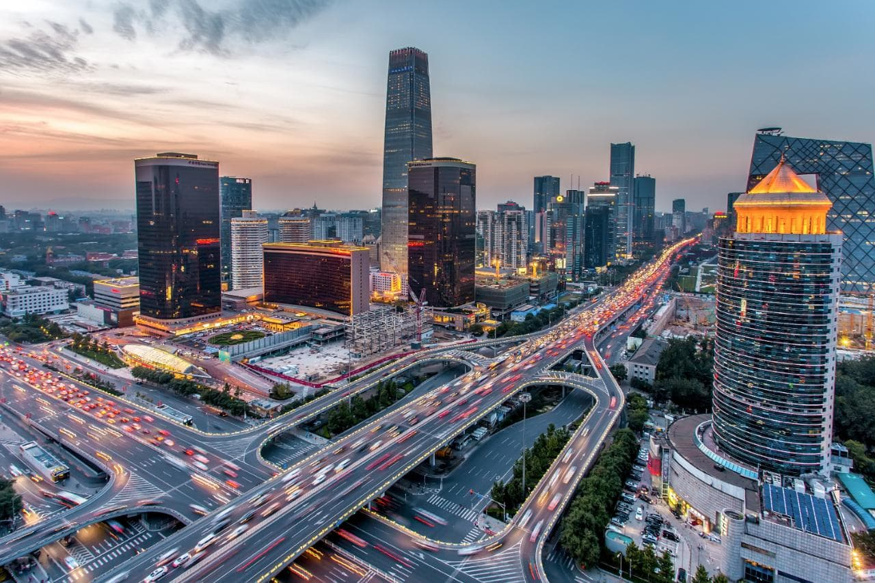

Some cities worldwide have already implemented some smart traffic management solutions based on the technologies mentioned in the previous chapter. Let’s examine some use cases so we can maybe get some inspiration.

### **Portland: SURTAC (Scalable Urban Traffic Control)**

**Key Features**

First, to promote scalability and reliability, SURTRAC operates in a totally **decentralized** manner; **each intersection independently and asynchronously allocates its green time**, based on current incoming vehicle flows. Decentralized control of individual

intersections enables maximum responsiveness to real-time traffic conditions. It promotes scalability by allowing incremental addition of intersections over time with minimal change to the existing

adaptive network. There is also no centralized computational bottleneck and no single point of failure.

Second, SURTRAC aims at managing urban (grid-like) road networks with multiple (competing) traffic flows; **network-level coordination** is accomplished by **communicating projected outflows to downstream neighbours**, which gives these intersections a more informed basis for locally balancing competing inflows while simultaneously promoting establishment of larger "green corridors".

Third, SURTRAC truly **operates in real-time**; each intersection recomputes its allocation plan and re-communicates projected outflows as frequently as once per second in rolling horizon

fashion, enabling both effective operation in tightly spaced signal networks and responsiveness to sudden changes in traffic conditions.

By using a novel reformulation of the optimization problem as a single machine scheduling problem, SURTRAC is able to compute near-optimal intersection control plans over an extended horizon on a second-by-second basis.

All that is needed for the software to operate is a connection to the existing detection system (generally video, but sometimes radar and loops), a similar connection to the signal controller, and then the ability to communicate to each immediate “neighbor” intersection in the grid.

Usually SURTAC is **run on a small computer in the traffic control cabinet but can sometimes be run from existing hardware already in the cabinet.**

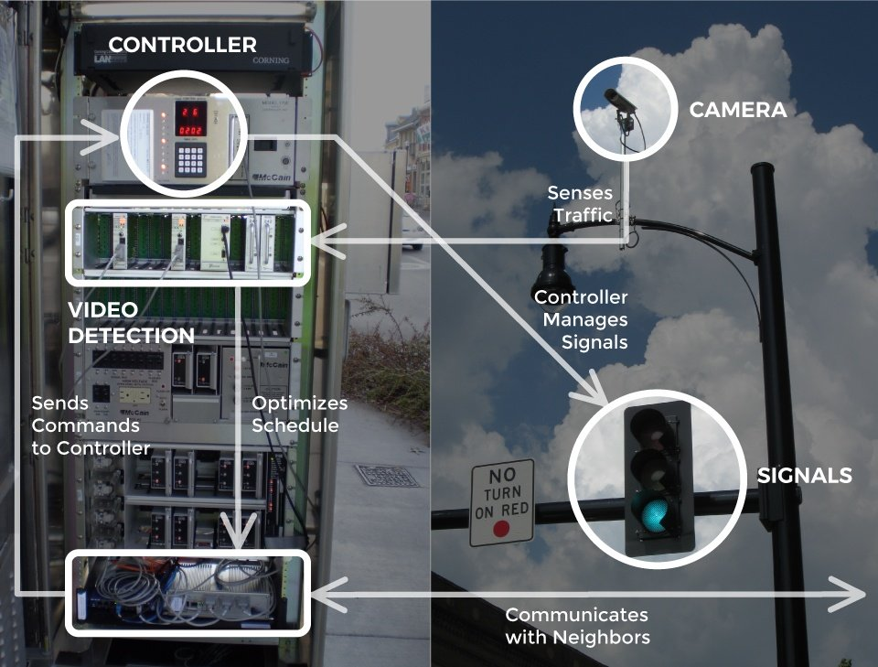**How SURTAC Works**

***Source****:* [*HOW DOES SURTRAC WORK?*](https://www.rapidflowtech.com/surtrac/how-it-works)

1. The first thing Surtrac does, like any good robotic system, is it senses its surroundings, or what is going on, in real-time, at the intersection. It gets this information from a software integration/API with the existing sensing infrastructure which can include cameras, radar, or even induction loops.
2. Surtrac processes this information and then, every second, via its patented scheduling software, creates an optimization plan for how to move multi-modal traffic through the intersection as efficiently as possible.
3. Next, via a second software integration/API, Surtrac acts on this plan by sending commands to the controller to coordinate the signals in support of its optimization plan.
4. Finally, Surtrac communicates information about its plan and the traffic that will flow from the intersection:

* To neighbouring intersections so that they can incorporate this information into their respective plans, which allows for both autonomy and coordinated control to happen naturally across the network as traffic conditions demand, as well as...
* To connected vehicles, passengers, pedestrians, or any other connected device or system that might have use for this information.

**Results**

****Given the following nine communicating intersections using SURTAC in East Liberty neighbourhood of Pittsburgh, Pennsylvania some evaluations were performed on emission savings and delay reductions.

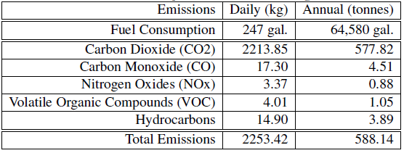**Emissions Savings**

Given an average of 29,940 vehicles per day, this table indicates projected savings in fuel and pollutant emissions. A daily savings in fuel of 24 gallons is estimated, which implies **a daily reduction in emissions of 2.253 metric tonnes**. Given this, an **annual reduction in emissions of 588 metric tonnes** is expected if SURTRAC continues to run the nine intersections at the pilot test site.

Also, **Portland** **reduced Delays** **by 20%** after deploying SURTAC in a very busy intersection.

*“After deploying Surtrac, Rapid Flow Technologies’ real-time, artificial intelligence (AI)*[*adaptive traffic signal control system*](https://www.rapidflowtech.com/surtrac/what-is-surtrac)*, the city of Portland experienced a* ***20% reduction in delays and a 16% reduction in travel*** *time through the “Morrill’s Corner” intersection system.”*

***Source****:* [*Portland Reduces Delays by 20% at Maine’s Busiest Traffic Intersection After Surtrac Deployment*](https://www.rapidflowtech.com/blog/portland-reduces-delays-at-maines-busiest-traffic-intersection-after-surtrac-deployment)

### **Toronto: InSync (Real-Time Adaptive Traffic Signal System)**

At November 24, 2017, the City of Toronto [launched a pilot project](https://www1.toronto.ca/wps/portal/contentonly?vgnextoid=af71df79b2df6410VgnVCM10000071d60f89RCRD&nrkey=15A3C057D3FBF0CC852581E20044624F) to implement smart traffic signals at 22 intersections across the city. InSync, deployed in 10 locations, uses video analysis camera detection.

According to acting Director of Traffic Management, Roger Browne, installing the Smart Signals costs approximately **$115,000 per intersection** and the city spent $903,000 in 2018 retiming 208 traffic signals in Toronto.

**How InSync Works**

InSync uses a rule-based Artificial Intelligence (AI) algorithm to compute real-time green durations to vehicle demand at each local intersection.

InSync knows the duration of wait times for every vehicle near the stop bar and the queue length for every lane. This information is collected **every second in real-time**. InSync **allocates a token for every unique car that joins the queue**. An **additional token is given to each car that waits every 5 seconds**.

The Greedy Algorithm changes the traffic signal light status to minimize the number of tokens issued. Thus, the local optimizer considers the number of cars waiting (real-time demand) and how long they have been waiting (delay).

This patented algorithm does not use outdated Webster-equation based modeling and is proven to produce unparalleled results in the field.

InSyncguarantees coordination between traffic signals (even unevenly spaced traffic signals) without increasing side street delay using a concept called “**Time Tunnels**.”

Time tunnels are created throughout the corridor (or grid network) with the slope of the tunnel indicating the speed of travel between traffic signals.

The scheduling of green for the coordinated phases are the top priority for the InSyncmodel. The coordinated phases are guaranteed to be green along the speed line and all other movements are scheduled around this.

The **point of initiation of green** for the coordinated phases are the **only fixed points** in the signal operation and all other points in time are **floating**. The tunnels can have variable duration based on demand or can be programmed to have a minimum green duration. The tunnels can be truncated based on demand, the green durations for various phases are based on the Greedy Algorithm, and the time-between-tunnels can vary as well. All of these processes happen in **real-time**.

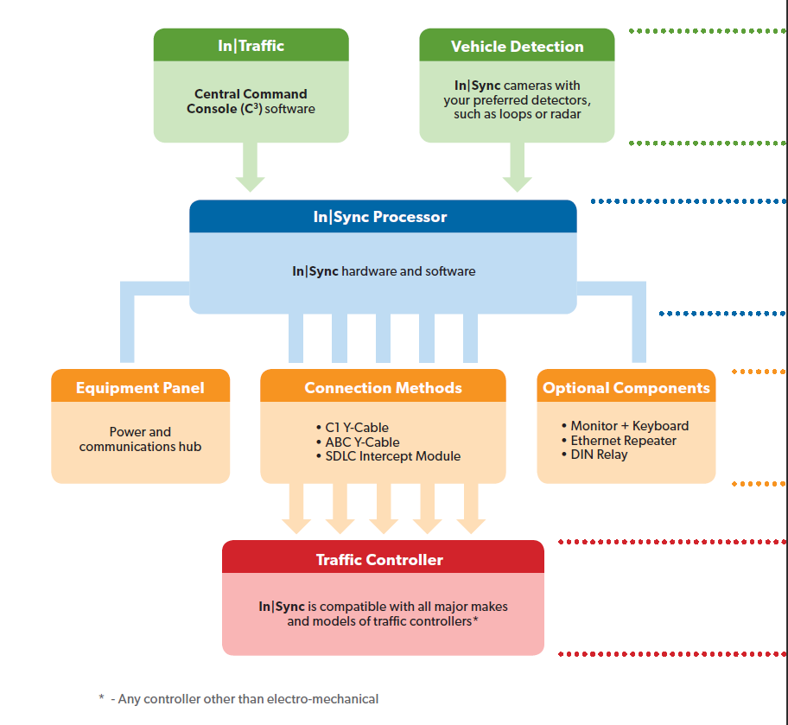**Architecture**

**The processor** is the heart of the InSync system. This environmentally hardened computer, installed in the traffic cabinet at each local intersection, holds all the artificial intelligence of the adaptive system. The InSync Processor gathers detection information from all sources available (cameras, loops, pedestrian push-buttons, etc.) and then determines the service priority for each approach. The processor places only two concurrently serviceable phases (state) to the existing traffic controller to actuate signal phases.

InSync also provides its own vehicle detection equipment. InSync cameras have thermal elements for use in the harshest winter environments and additionally they **use thermal imaging for vehicle detection**.

Thermal imaging and heat-signature detection eliminates the effect of inclement weather and conditions such as sun glare shadows, rain, fog.

**Results and Benefits**

* Vehicle **emissions** and fuel consumption **reduce by 34%**.
* Proven to reduce delay by 73%.
* Proven to reduce crashes by 15%-30%.
* Proven to reduce vehicle stops by 80%.
* Proven to have the least amount of down time compared to other similar systems.

**Emission and Money Savings**

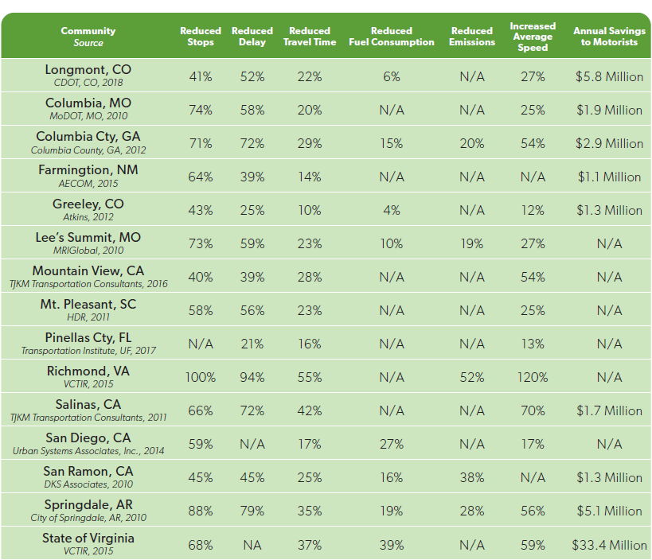

**Source for information about InSync:** [**INSYNC PRODUCT CATALOG**](https://trafficbot.rhythmtraffic.com/wp-content/uploads/InSync-Catalog-v16.0_Dec2019.pdf)

### **Singapore: GLIDE (Green Link Determining)**

The Green Link Determining (GLIDE) system controls all traffic signals in Singapore by adjusting the green time as traffic flow changes. GLIDE also links adjacent traffic signals to allow vehicles to travel from one junction to another with minimal stops. **GLIDE uses loop detectors to detect the presence of vehicular and pedestrian traffic** and makes traffic signal adjustments to:

* Allocate green time for motorists and pedestrians based on demand
* Provide "green wave" link between adjacent junctions to minimize the number of stops by vehicles
* Allow traffic signal faults to be rectified quickly

**How GLIDE Works**

The GLIDE system detects the presence of vehicles and pedestrians at the traffic light junctions and uses logic and algorithms to analyse real-time traffic data.

**Wire sensors laid beneath the road surface at junctions sense the presence of vehicles**. This activates a local controller that adjusts the traffic light timing so that more green time is given to the direction with a higher traffic volume.  
  
The GLIDE system also **detects pedestrians when they press the push button at the junction**. In the past, without the push buttons, the “green man” would be turned on automatically. A push button system at traffic signals allows “green man” to be activated only when pushed, so that motorists do not need to wait at the red light unnecessarily and they can enjoy more green time when there are no pedestrians crossing the road.  
  
The GLIDE system links the traffic signals at adjacent junctions along the major corridors, by coordinating the start of their green times. **This allows motorists to catch the "green wave" and travel from one junction to another without having to stop at the red lights as often.**

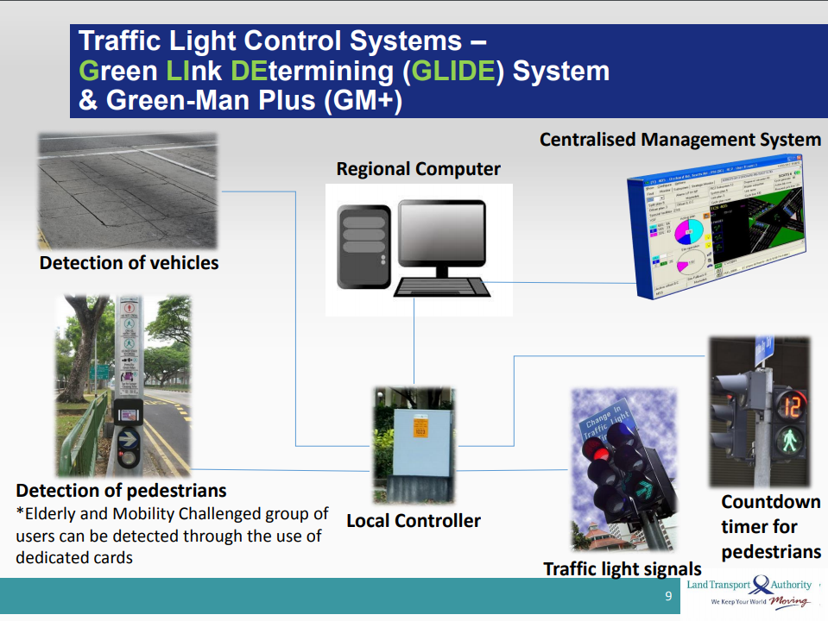

***Source****:* [*ITS Development in Singapore*](http://itsasia-pacific.com/wp-content/themes/its/images/CountryReport_Singapore.pdf)

### **Darmstadt, Germany: Video Detectors with FLIS Systems**

As part of a larger urban zone across the southern part of the German Rhine Main Area, the city of Darmstadt near Frankfurt, Germany has implemented a very elegant and minimalist solution to manage traffic congestion, cyclist safety and pedestrian safety. In order to make intelligent traffic management possible and make traffic flows smoother**, the city’s traffic authorities have installed more than 200 video detectors** from FLIR Systems. The city also makes use of FLIR’s video management system FLUX which visualizes the traffic streams coming from a wide variety of cameras.

Stefan Hartmann, Traffic Engineer at the Darmstadt Traffic Administration comments: “Video detectors have proven to be very suitable for traffic dependent control, especially when you take into account the wide variety of applications. With the video detection sensors from FLIR, we have been able to significantly improve the quality of traffic-dependent control as compared to the use of induction loops.”

A major advantage of video detection over induction loops is that no extensive civil engineering is required, and no outside companies need to be commissioned to install in-road loops. The technicians at the city of Darmstadt can simply install the cameras where they want themselves, wire them up and configure them.

The city of Darmstadt is using various types of video sensors for vehicle, pedestrian and bike detection, all of which are used to control traffic flows in a more intelligent way. This has made the inner-city traffic a lot safer and more efficient. In certain parts of the city, video detectors allow the traffic authorities to detect congestion so that if there is an increase in the flow of traffic, **the green signal can be extended to allow the traffic jam to dissipate.**

**How This Video Detection System Work**

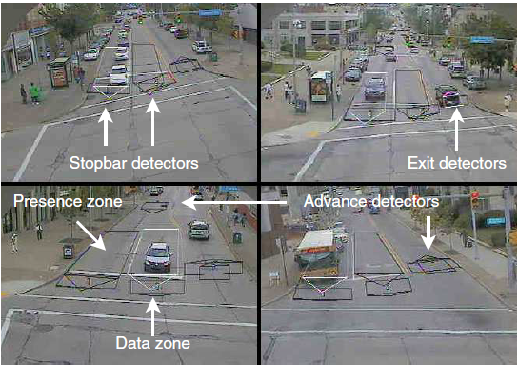

***Source****:* [*SURTRAC: Scalable Urban Traffic Control*](https://www.semanticscholar.org/paper/SURTRAC%3A-Scalable-Urban-Traffic-Control-Smith-Barlow/8409ceb8345498c0c5bf71e598db0d6003dea5e8)

This figure shows the placement of detectors at a typical intersection. For each exit link, a group of exit detectors is placed near the intersection. For each entry link, a group of stop-bar detectors is placed near the intersection, and a group of advance detectors is placed far away from the intersection. To maximize the look ahead

horizon, the exit detectors of an upstream intersection are used as the advance detectors for the downstream intersection. For intersections on the boundary of the system, advance detectors

might be located closer to the intersection.

At each detection location, two types of data are reported: **traffic counts and occupancy time of vehicles**. For the video detection in the pilot system, these two measures are generated by

separate detection zones: **a data zone and a presence zone**. **Data zones** are small enough to **detect gaps between vehicles** during congested conditions, whereas **presence zones** arelarge enough to **prevent missing vehicle occupancy information**.

As a vehicle passes a data zone, a message isgenerated and sent to the local Scheduler as well as any relevant neighboring intersections. Occupancyfor all presence zones is sensed every 0.1 seconds and aggregated every second, encodedinto messages, and sent through the Communicator in the same way.

**Pedestrian Safety**

In other cases, video detection is used to improve the safety of pedestrians. When school is out, there is a lot of pedestrian traffic from students. To guarantee the safety of schoolchildren and passers-by, [FLIR C-Walk sensors](http://www.flir.com/traffic/display/?id=61995) have been installed to detect large groups of people and to adapt the green phase of the traffic signal system accordingly. This way, pedestrians have a reasonable amount of time to cross the street safely. Traffic safety and efficiency always need to go hand in hand. That’s why in any installations, a pedestrian sensor installation is completed with a vehicle presence sensor. In the installation in the Darmstadt-Bessungen sub-district, a [TrafiCam vehicle presence sensor](http://www.flir.com/traffic/display/?id=61992) ensures a normal flow of traffic. It will detect the presence of a car or a tram on the street, and if a pedestrian presses the button, the traffic is first allowed to dissipate, ensuring that the flow of traffic is not interrupted.

**Bicyclist Safety**

[ThermiCam](http://www.flir.com/traffic/display/?id=62071)is an integrated thermal camera and detector for vehicle and bike detection and does not need light to operate. Instead, **it uses the thermal energy emitted from vehicles and bicyclists to detect both in the darkest of nights**, over a long range and in the most difficult weather conditions. [ThermiCam](http://www.flir.com/traffic/display/?id=62071) can be used to control traffic lights by detecting vehicles and bicycles at and nearby the stop bar. **The intelligent ThermiCam sensor will transmit its detection information over contact closures or over IP to the traffic light controller and will thus allow a more dynamic control of traffic lights**. Typical intersection applications are ‘green on demand’ and ‘lengthening green times’.

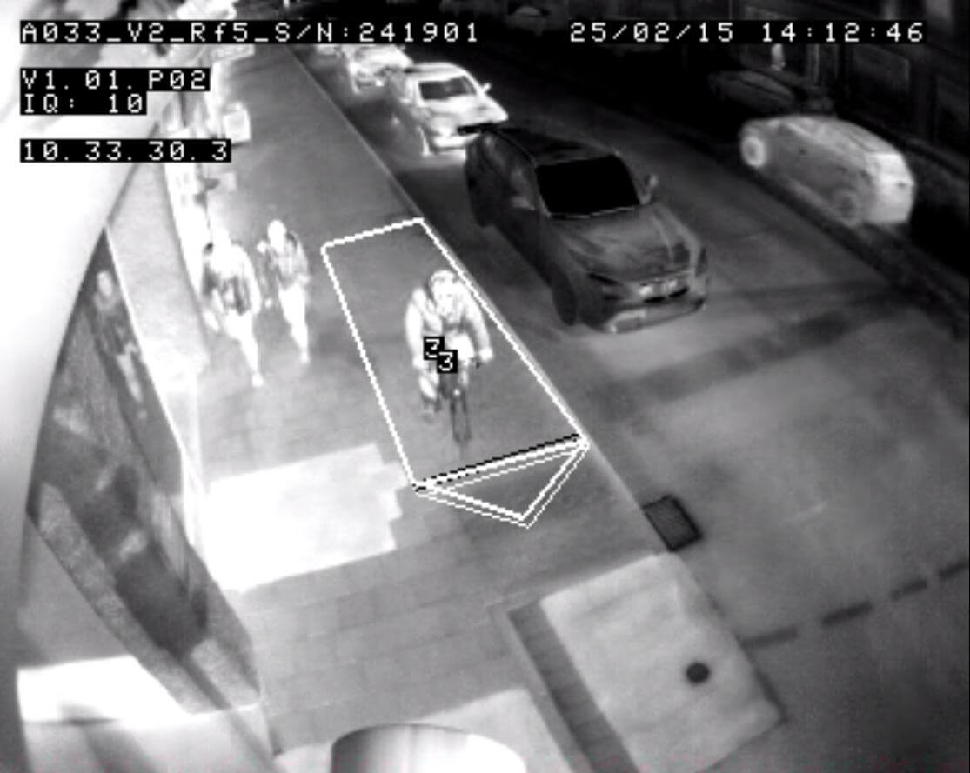

**Source about Darmstadt:** [**Smart traffic management in the city of Darmstadt**](https://www.flir.com/discover/traffic/roads-tunnels/smart-traffic-management-in-the-city-of-darmstadt/)